Lab-6.4
NAME :
veeramalla praneeth
Roll No : 2303A52146
Batch : 41
Task 1: Student Performance Evaluation System
Scenario
You are building a simple academic management module for a university system where student performance needs to be evaluated automatically. Task Description
Create the skeleton of a Python class named Student with the attributes:
- name
- roll_number
- marks
Write only the class definition and attribute initialization. Then, using GitHub Copilot, prompt the tool to complete:
- A method to display student details
- A method that checks whether the student’s marks are above the class average and returns an appropriate message
Prompt :
Create a Python class named Student with attributes name, roll_number, and marks . Add a method to display student details .
Add a method that checks whether the student's marks are above the class average .

CODE :

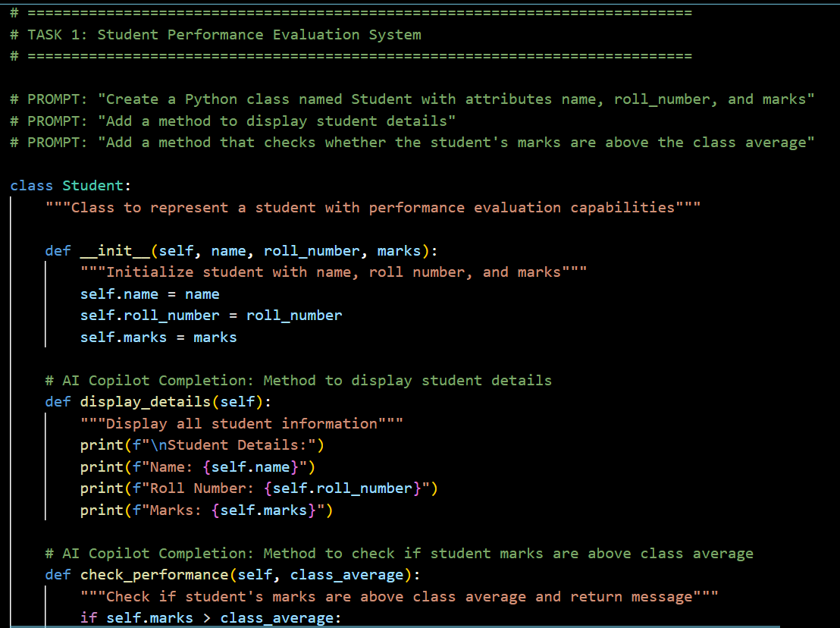

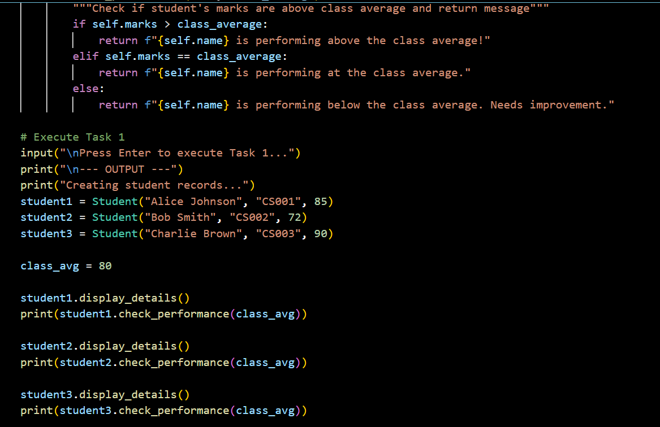
Output :
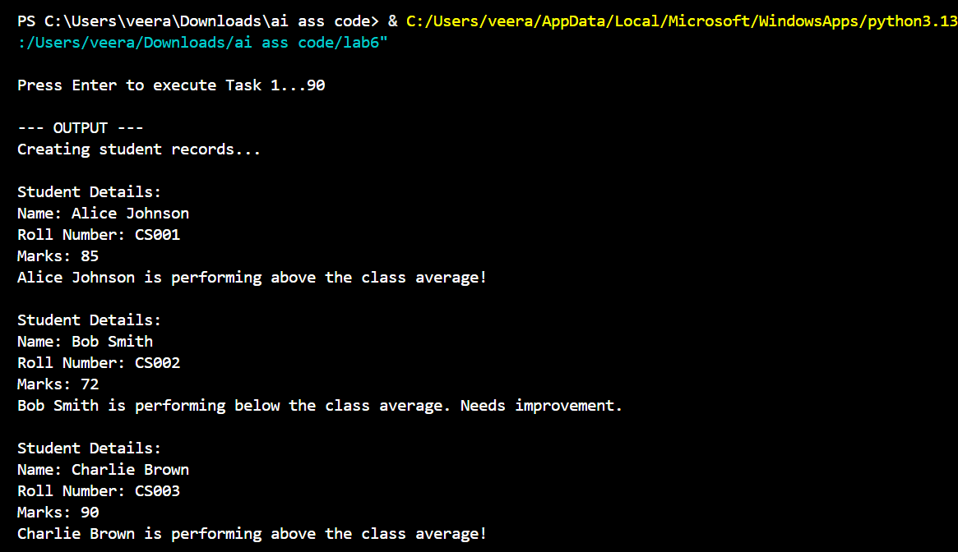
Justification :
This task demonstrates the application of object-oriented programming concepts such as classes, objects, constructors, and methods to model student data. AI-assisted
code generation helps in structuring the program efficiently and implementing performance evaluation logic based on class averages, improving maintainability and readability of the code.

Task 2: Data Processing in a Monitoring System Scenario
You are working on a basic data monitoring script where sensor readings are collected as numbers. Only even readings need further processing. Task Description
Write the initial part of a for loop to iterate over a list of integers representing sensor readings.
Add a comment prompt instructing GitHub Copilot to:
- Identify even numbers
- Calculate their square
- Print the result in a readable format

Allow Copilot to complete the remaining loop logic.
Prompt :
Write a for loop to iterate over a list of sensor readings . Identify even numbers using modulus operator .
Calculate the square of even numbers and print in readable format .
Code :
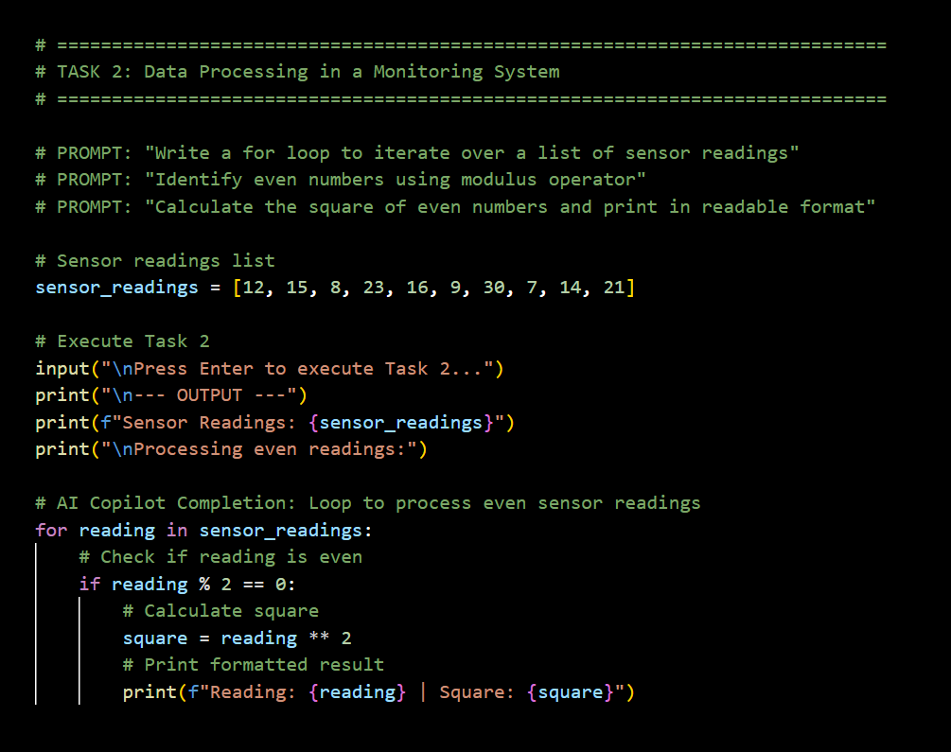
Output :
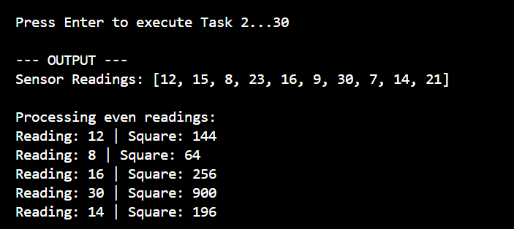

Justification :
This task shows how looping structures and conditional checks are used to analyze sensor readings systematically. AI-generated code reduces manual effort in writing repetitive logic for filtering values and performing calculations, ensuring faster development and accurate data processing.
Task 3: Banking Transaction Simulation Scenario
You are developing a basic banking module that handles deposits and withdrawals for customers.
Task Description
Create the structure of a Python class named BankAccount with attributes:
- account_holder
- balance
Use GitHub Copilot to complete methods for:
- Depositing money
- Withdrawing money
- Preventing withdrawals when the balance is insufficient Guide Copilot using method names and short comments. Prompt :
Create a class BankAccount with attributes account_holder and balance . Add a method to deposit money into the account .
Add a method to withdraw money with balance validation . Prevent withdrawals when balance is insufficient .

Code :
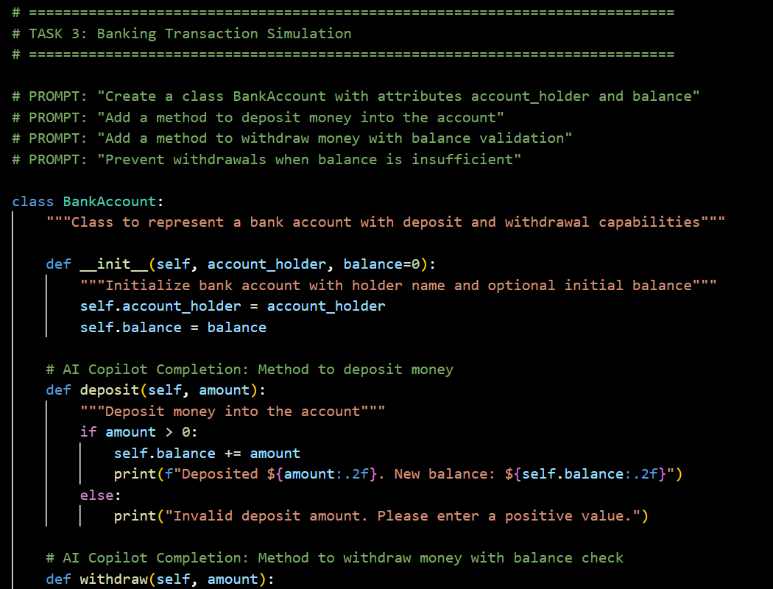

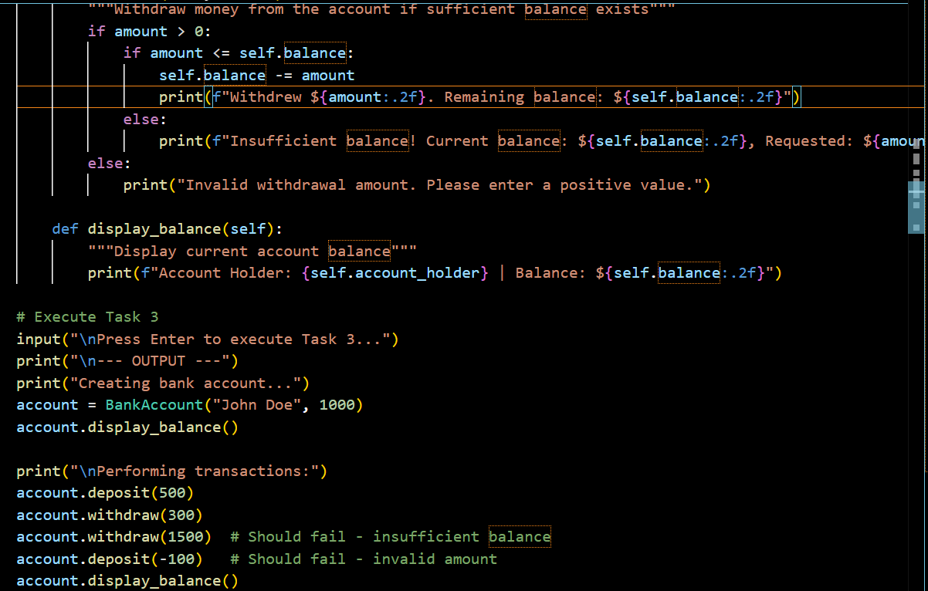
Output :
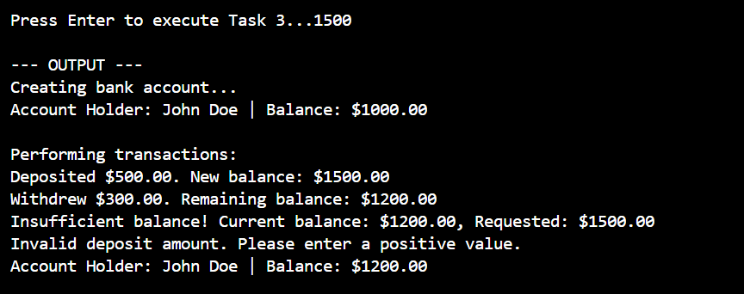

Justification :
This task represents real-world banking operations by implementing secure deposit and withdrawal functionality using proper validation rules. AI-assisted coding supports the correct use of conditions and class methods to prevent invalid transactions, making the system reliable and user-safe.
Task 4: Student Scholarship Eligibility Check Scenario
A university wants to identify students eligible for a merit-based scholarship based on their scores.
Task Description
Define a list of dictionaries where each dictionary represents a student with:
- name
- score
Write the initialization and list structure yourself.
Then, prompt GitHub Copilot to generate a while loop that:
- Iterates through the list
- Prints the names of students who scored more than 75 Use comments to guide Copilot’s code completion.

Prompt :
Create a list of dictionaries with student name and score . Write a while loop to iterate through the student list .
Print names of students who scored more than 75 .
Code :
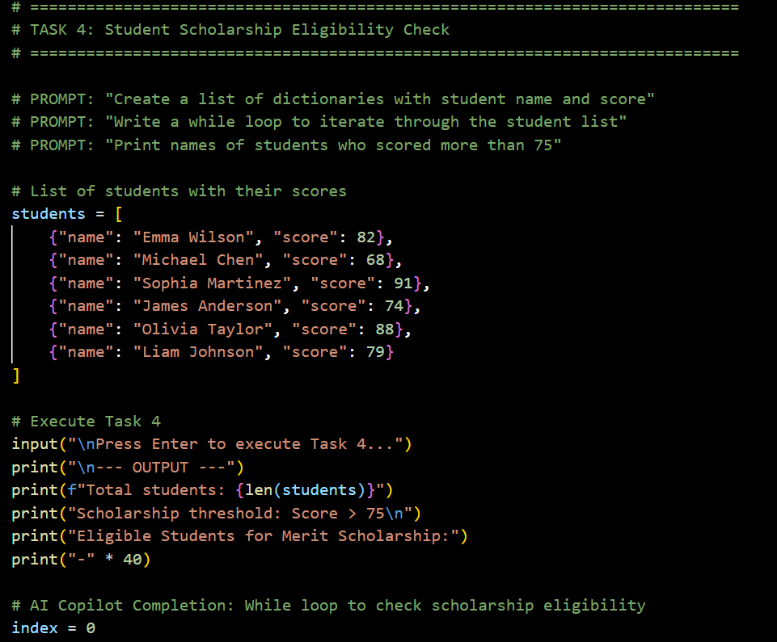
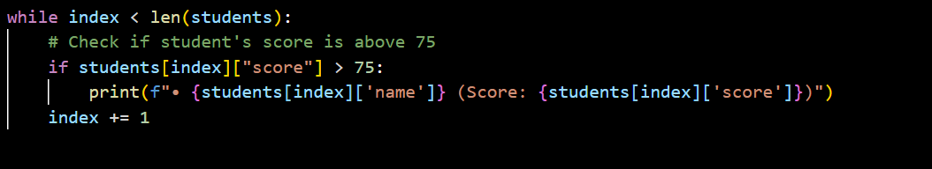
Output :
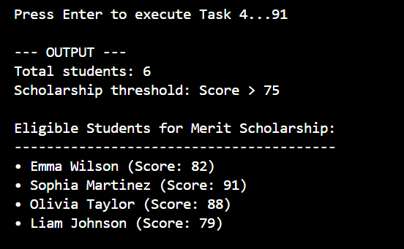

Justification :
This task emphasizes the use of iterative control structures and list handling to process multiple student records. AI-based code completion helps automate the evaluation of eligibility criteria, making the decision-making process efficient and consistent.
Task 5: Online Shopping Cart Module Scenario
You are designing a simplified shopping cart system for an e-commerce website that supports item management and discount calculation.
Task Description
Begin writing a Python class named ShoppingCart with:
- An empty list to store items (each item may include name, price, quantity)
Use GitHub Copilot to generate methods that:
- Add items to the cart
- Remove items from the cart
- Calculate the total bill using a loop
- Apply conditional discounts (e.g., discount if total exceeds a certain amount)
Use meaningful comments and method names to guide Copilot.
Prompt :
Create a class ShoppingCart with an empty list to store items .
Add a method to add items to the cart with name, price, quantity. Add a method to remove items from the cart by name .
Add a method to calculate total bill using a loop .
Add a method to apply conditional discounts based on total amount .

Code :
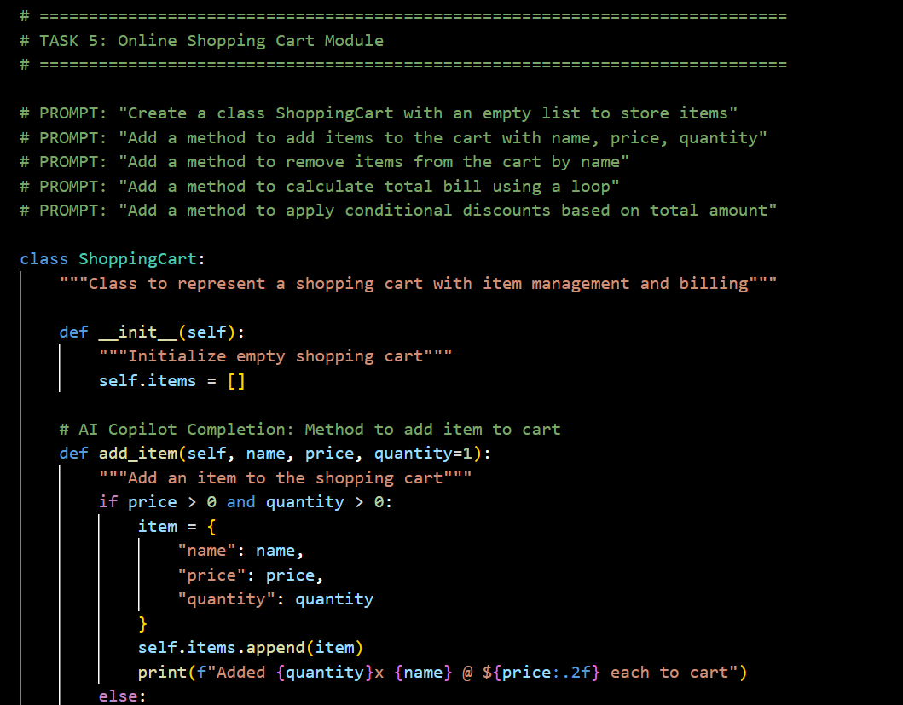

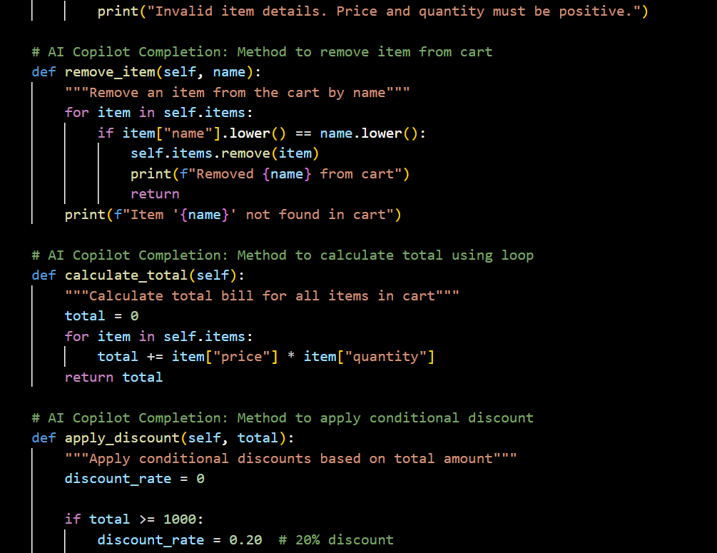

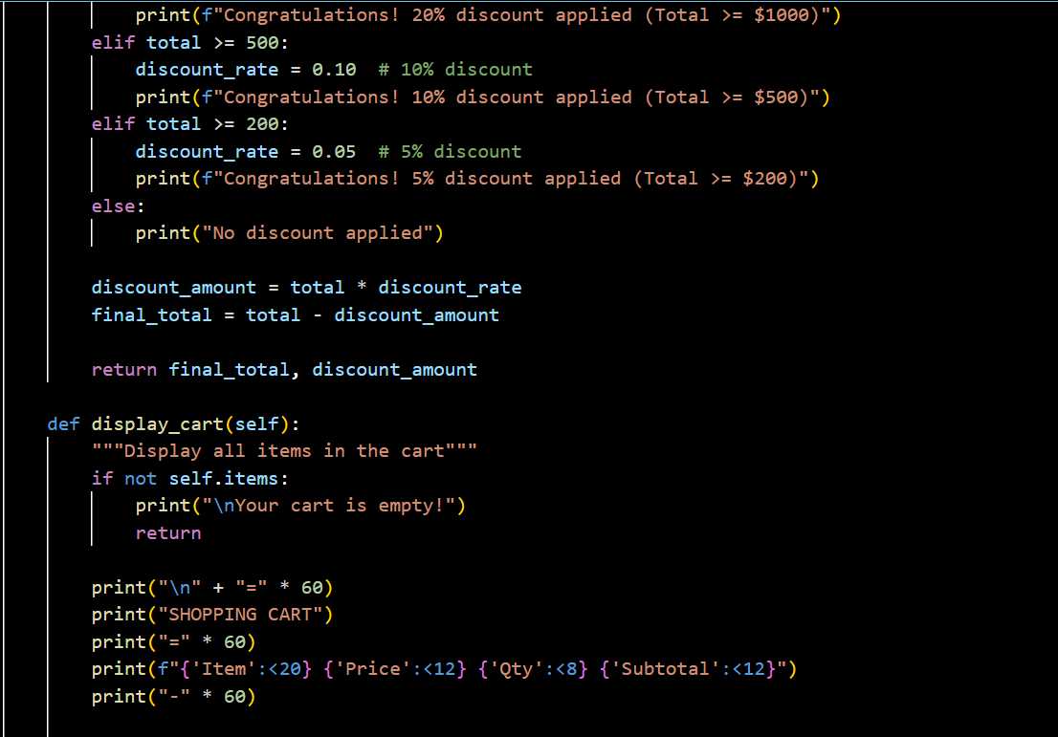

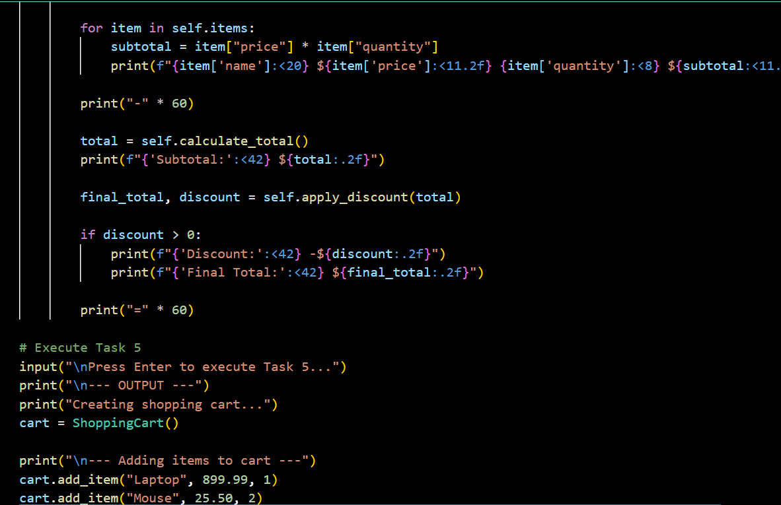

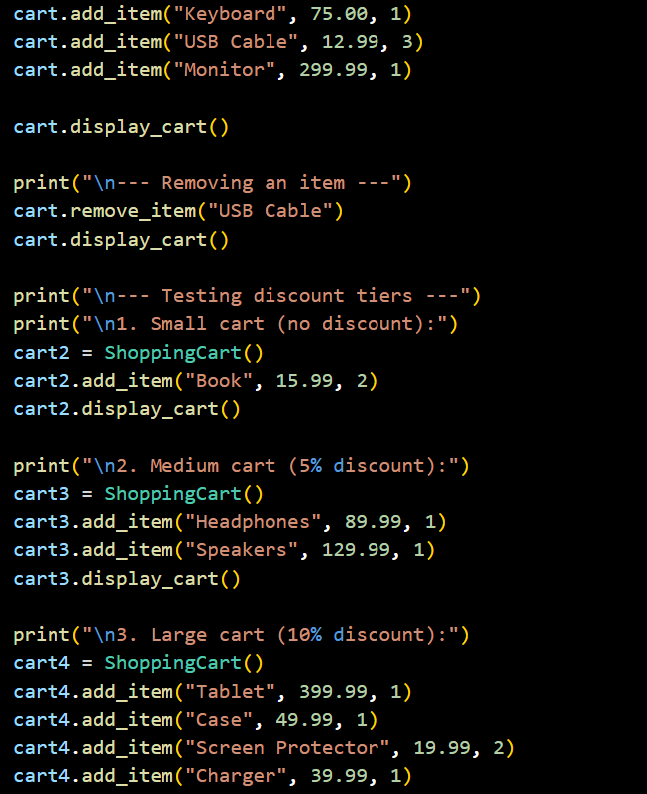

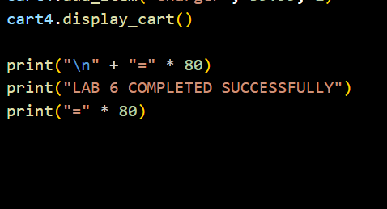

Output :

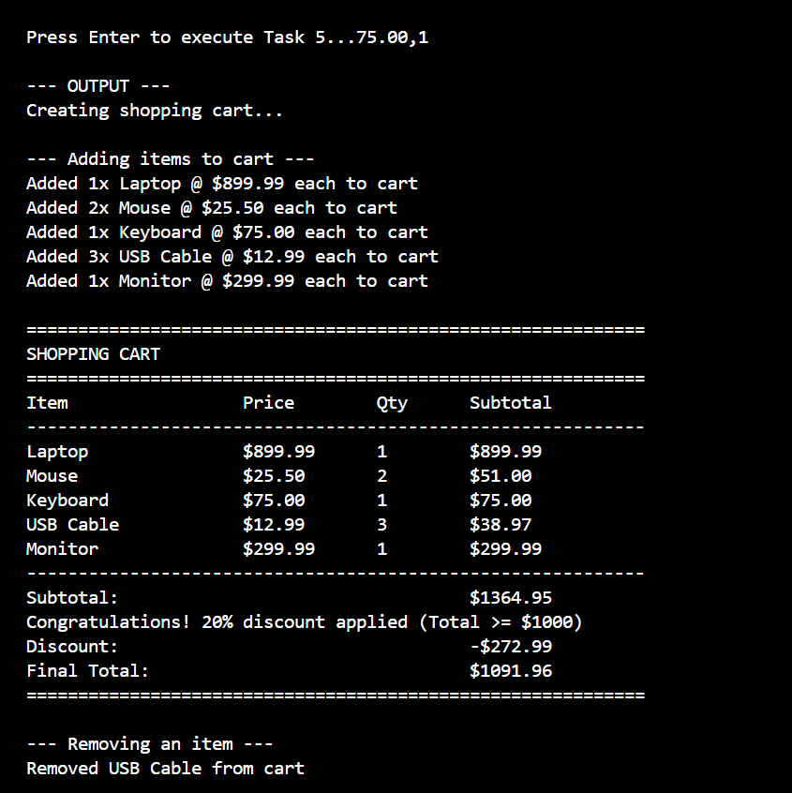

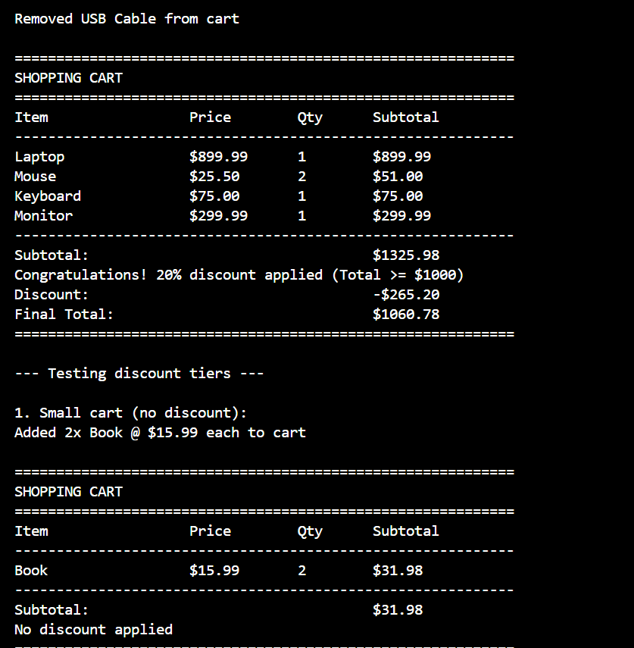
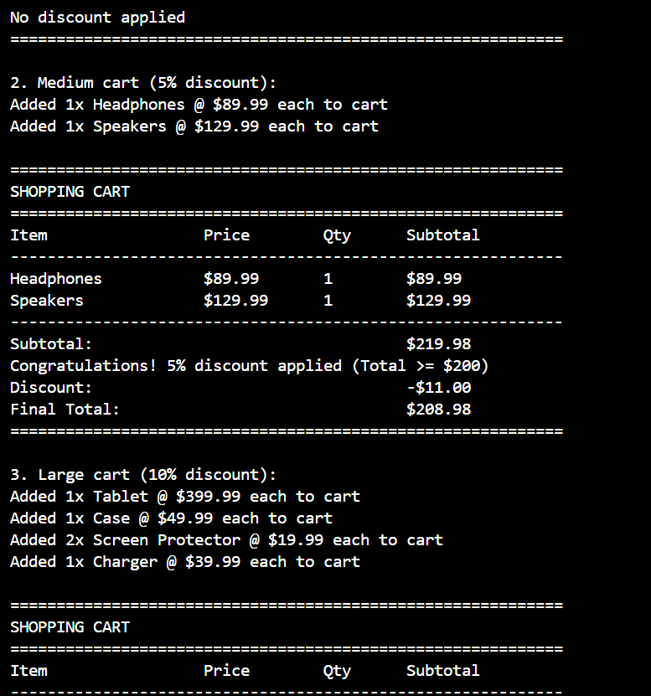

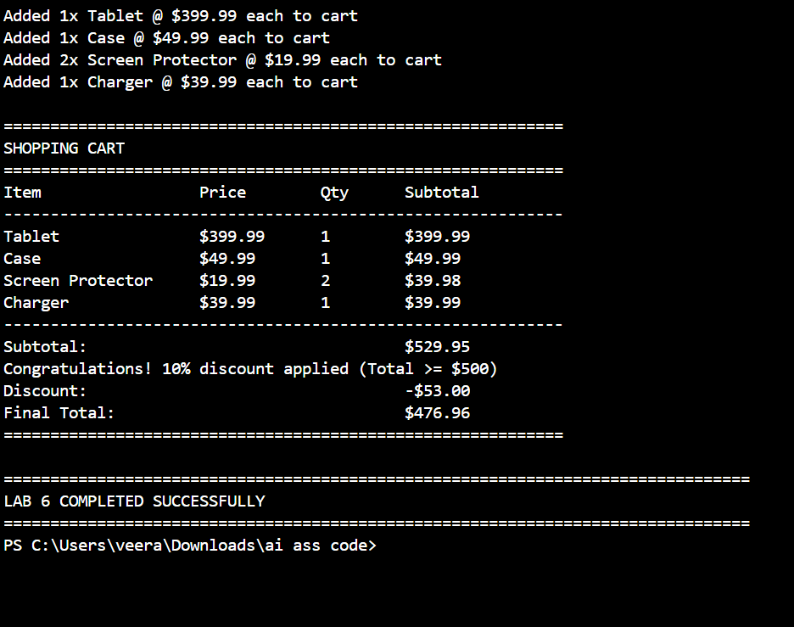

Justification :
This task demonstrates how multiple programming concepts are combined to build a functional shopping cart system. AI-generated code simplifies the implementation of product handling, price calculation, and discount application, resulting in a scalable and realistic e-commerce simulation.

